**Executive Summary**

**Campaign Overview:** Nomz, Inc. is a New York City (NYC) based startup providing convenient, traditional, and healthy frozen soup for busy Asian American individuals. The company was founded in August 2015 and currently only offers two products, Chinese Chicken Shiitake Mushroom Soup and Vietnamese Pho Soup. The two objectives of the Google Online Marketing Challenge (GOMC) were to raise brand awareness and company sales. Our campaign goals were to achieve a click-through-rate (CTR) of 2%, an average cost-per-click (CPC) of $0.83, receive 300 clicks, and generate $300 worth of additional sales through GOMC. We ran Google AdWords for a period of 18 days, from April 11th to April 29th.

**Key Results:** We managed to generate $114.60 in sales through GOMC, achieve 220 clicks over the 18 days and maintain an overall CTR of 14.97% with an average CPC of $1.04. The only two Campaigns that received clicks were Brand and Products with 212 clicks and 8 clicks respectively. The most successful Ad Groups were Nomz, EatNomz, Chinese Soup, Eat Nomz, and Frozen Pho, with CTRs of 49.48%, 64.29%, 1.60%, 37.50%, and 50.00% respectively.

**Conclusion:** As the company is still relatively young, we feel that its lack of ability to generate sufficient search volume for related keywords showed that it is not currently ready to use Google AdWords as a marketing tool. We learned that employing social media platforms, popular NYC food blogs, and personal outreach are currently more effective means of marketing the company’s brand and products. Additionally, there is substantial search volume in NYC for the product category that Nomz carries, and therefore potential to capture clicks from such searches.

**Future Recommendations:** Nomz should continue to build and strengthen its brand awareness first through the use of social media platforms such as Facebook and Instagram and AdWords in future. It should also switch to a WordPress front end with a Shopify backend e-commerce plugin for its website. This would allow Nomz to use SEO plugins such Yoast to strengthen its user Landing Page Experience. Additionally, Nomz should advertise its products on Google Shopping Ads through AdWords. Lastly, Nomz should hire a dedicated marketing expert to help manage its marketing strategy and implement all the recommendations stated above.

**Industry Component**

**Campaign Overview:** The primary objectives of the GOMC campaign was to raise brand awareness and sales for Nomz. We had planned to achieve a CTR of 2%, an average CPC of $0.83, receive 300 clicks, and generate $300 worth of incremental sales. We were successful in raising brand awareness for the company, but only with the help of a three pronged strategy we employed midway into the campaign. The three pronged approach consisted of promoting a raffle event on Facebook, reaching out to personal contacts, and releasing publicity articles on major NYC food blogs. We monitored and experimented with different keywords, ad groups, and ad copies in order to generate search impressions and capture clicks. In total, we experimented with a total of 12 campaign groups, including two shopping ads campaigns, but ultimately only received clicks from two campaigns, Brand and Products. The Brand campaign accounted for over 96% of the clicks received. There were a total of seven ad groups that received clicks, three of them were under the Brand campaign. We ran Google AdWords for a period of 18 days, from April 11th to April 29th, and spent a total of $228.06.

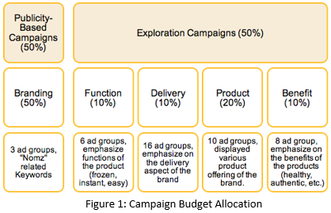**Campaign Strategy Adjustments:** After conducting a search and web analysis on our client’s website, our team quickly realized that we needed to first generate impressions for our clients before generating clicks. Prior to the GOMC campaign, Nomz’s website only received about 140 sessions per week. This traffic would only have brought us approximately 100 clicks for the entire campaign, assuming 25% of the traffic came from paid search. Therefore, in addition to the GOMC campaign, we launched a side publicity campaign to raise greater brand awareness for our client.

We adjusted our AdWords budget to complement this side publicity campaign. The final budget sheet is displayed in Figure 1. Overall, we decided to allocate 50% of the budget to complement the side publicity campaign and the remaining 50% to the “Product”, “Frozen”, “Healthy”, and “Promotions” campaigns.

After communication with our client, we came up with two promotions to help us increase CTR. The first promotion, which started during week 1, was a 10% discount code applicable at checkout. This promotion was primarily used for the **Exploration Campaigns** to increase CTR. The second promotion was a raffle, in which up to two people could win 10 soups for themselves and two of their friends. The raffle started in the beginning of the second week. This promotion was used primarily for the **Publicity-Based Campaigns** to promote click conversion.

The side publicity campaign primarily utilized three channels: Press Releases (releasing articles on major NYC food blogs), Social Media (in particular Facebook), and Personal Connections. For press releases, we contacted ten major Asian American Blogs and Online Magazines to publish an article or interview about the Nomz Brand. Four of the media outlets agreed to release those publicity materials and released them throughout the second and third week.

The Facebook campaign consisted of three components: 1) an Event Boosting campaign that publicized the Nomz Raffle Event ($200), 2) a Post Boosting campaign that complemented the press releases ($150), and 3) a Page Boosting campaign that attempted to draw more traction for the Nomz brand and attract more Likes to the Nomz Page ($50).

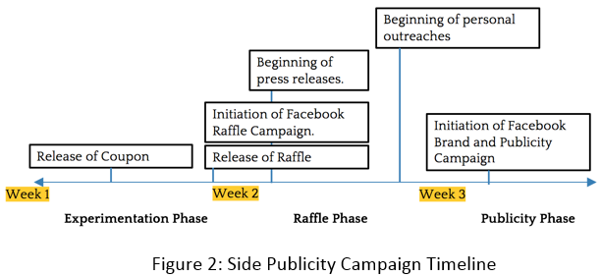Finally, we also reached out to three groups of individuals through email or word or mouth to gain more traction for the Nomz brand: 1) Founder’s personal connections in New York 2) Our own connections who were either in New York or were moving to New York within 3 months, and 3) Asian Organizations in New York. The timeline of the side publicity campaign is shown in Figure 2.   
**Operational Adjustments:** During our GOMC campaign, we also made a few major adjustments to our AdWords campaign based on the number of clicks and impressions received. During the first week, the Product campaign received 556 impressions while only receiving 7 clicks. At the same time, Function and Benefit campaigns generated 110 and 14 impressions respectively with zero clicks each. Furthermore, click-generating keywords had below average Landing Page Experience ratings. In order to increase CTR across the **Exploration Campaigns**, we conducted four experiments. First, we came up with four new ad copies for the ad groups of the Product campaign in order to identify whether ad copy quality was the cause of a low CTR. Secondly, we increased the discount promotion from 10% to 30% and displayed the promotion code on the ad copy to entice 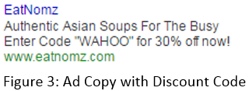search users to click on the ad. An example ad copy is shown in Figure 3. Thirdly, we added a new campaign, Delivery, which included ad groups that competed in the Asian food delivery and meal subscription landscape in NYC. Lastly, we also set up a Google Shopping Ad campaign in order to capture clicks from search terms such as “Asian soup” and “Chinese soup”. Unfortunately, none of those efforts ultimately improved the CTR of the **Exploration Campaigns**. Overall, those campaigns generated 1046 impressions and only 8 clicks. On the other hand, the **Publicity-based campaigns** generated 194 clicks with only 358 impressions. Therefore, in order to prevent further impression leak, we decided to pause all **Exploration Campaigns** at the end of the second week.

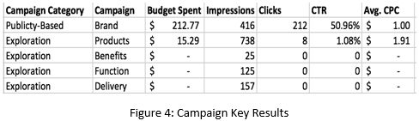**Key Results:** Overall, our campaigns received 1,461 impressions and 220 clicks, with a CTR of 15.06%. Our GOMC campaign also brought about an incremental revenue of $114.60 for Nomz. A detailed breakdown of clicks and impressions by campaign is displayed in Figure 4. The Brand campaign generated 96.37% of the clicks for the entire GOMC campaign, maintained an average CPC of $1.00, and a CTR of 50.96%, illustrating the effectiveness of our publicity efforts. Within the Brand campaign, the best performing keyword was “[nomz]”, which received 282 impressions, 162 clicks, a CTR of 57.45%, and average CPC of $0.93. Other campaigns, however, returned suboptimal results. Only Products campaigns generated 8 clicks, at the cost of 738 impressions with average CPC of almost double that of the previous campaign. The best performing keyword in the Product campaign was “chinese noodle soup”, which received 5 clicks, 300 impressions, 1.66% CTR, and average CPC of $1.71.

Because we released different parts of the publicity campaign in different times, we were able to identify the impact of each effort. The impact of the discount promotion released in the beginning of the campaign was limited and generated on average 5 clicks per day, with 3 or 4 clicks from the Brand campaign. The raffle campaign generated on average 10-15 clicks per day. The press releases and related Facebook advertising and personal outreach efforts generated additional 10-15 clicks. However, we discovered that the effect of press publicities were short lived - the click lift diminished one day after the last article was released. The effects of raffle also diminished at the end of the third week, resulting in an unexpected click decline approaching the end of the campaign. The overall campaign trajectory is displayed in Figure 5. 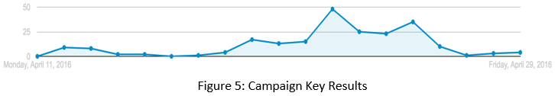

Our campaign had two primary objectives: generate revenue and improve brand awareness. In terms of revenues, we had generated $114.60 in revenue for Nomz. Even though the ROI of the entire campaign was only 20.72% (cost of $550), the revenue generated throughout the campaign was over 10% of the company’s sales during the GOMC weeks. Regarding brand awareness, we measured our results using both Facebook and Google Analytics. Our Facebook campaigns reached a total of 16,511 people in the Manhattan Area with over 250 post engagements. Likes on Nomz’s Facebook page increased from 289 to 367 during the GOMC, a very drastic increase. In terms of web metrics, over 930 visitors visited eatnomz.com and engaged in 1,336 sessions. Comparatively, only 412 visitors visited eatnomz.com during the same period before the GOMC and engaged in only 588 sessions. This results were astonishing because it the site traffic more than doubled (225% increase) as result of our campaigns.

**Conclusions:** Our primary objectives of the GOMC campaign were to 1) generate additional revenue and 2) promote brand awareness for Nomz, Inc. In order to achieve these objectives, we had to expand the scope of our campaign to include an additional multi-channel side publicity campaign. Overall, we achieved mixed successes with our campaigns. For the GOMC Campaign, we have generated 220 clicks out of 1,461 impressions with a CTR of 15.06%. We generated $114.60 revenue for our client, 78 additional likes on their Facebook page, and more than doubled their site traffic during GOMC weeks. Despite setbacks in the **Exploration Campaigns**, our **Publicity-Based Campaigns** achieved great success both in terms of click conversion and traction acquisition. Our GOMC experience was by all means unique, working with an early-stage startup meant that we could not achieve our projected goals without additional efforts in publicizing and promoting the brand outside of using AdWords. Those additional campaigns enabled us to gain a more complete overview of the digital marketing world and offered us valuable lessons and skills that both benefited us and our client.

**Future Recommendations:** In the immediate future, Nomz should focus its marketing efforts on building brand awareness through major NYC food blogs and social media platforms such as Facebook and Instagram. Nomz should only start employing Google AdWords as a marketing tool once it has built a stronger brand name. We feel that the company currently does not have a strong enough brand name for there to be sufficient search volume relating to its company or products to efficiently use AdWords. It should also consider running Google Shopping Ads on AdWords in future. Additionally, Nomz should switch to a WordPress front end with a Shopify backend e-commerce plugin for its website. This would allow Nomz to use SEO plugins such as Yoast to strengthen its user Landing Page Experience. Lastly, Nomz should continue to monitor its website’s user engagement performance through Google Analytics to better employ AdWords.

**Learning Component**

**Learning Objectives and Outcomes:** By participating in the Google Online Marketing Challenge we hoped to learn how to drive traffic to the website via promotions, how to market effectively through different digital channels (such as Facebook), how to use Google AdWords effectively, how to effectively manage an AdWords campaign as a team, and how to evaluate different AdWords performance metrics, so as to optimize campaign performance. Overall, we were able to meet the learning objectives we set out to accomplish, becoming proficient in Google AdWords.

The start of our campaign was very challenging, but this forced us to think outside the box and expand our promotion strategy to include Facebook advertising and analytics on Facebook post reach and clicks. We had several critical takeaways from this experience.

First, don’t bid on competitive keywords. In our exploration campaigns we bid on competitive keywords, such as “chinese soup,” which generated a large number of impressions. Overall, our exploration campaigns generated over half of our impressions while producing only 8 clicks. In retrospect, we should have paused these campaigns earlier on in the competition. Second, test rapidly and fail quickly. Our coupon promotion during week one was ineffective, even after we increased the discount from 10% to 30% off of the product’s price. In retrospect, we should have started the raffle promotion as soon as we realized that the coupon promotion was not driving a substantial amount of impressions and clicks. Third, plan ahead for uncertainty. Our press releases were repeatedly pushed back by the publishers, and were consequently released much later than we had anticipated. In retrospect, we should have taken this potential lag time into consideration and reached out to the publishing companies earlier. Additionally, we did not have a backup plan for these press releases. Prior to the start of the campaign, we should have created several backup plans that we could have implemented when the press releases were delayed.

**Group Dynamics:** Our group dynamic evolved throughout the entirety of the GOMC. Our vastly differing schedules made in-person collaboration challenging. At the start of the GOMC, our communication was sporadic. However, halfway through the competition we began to change our communication habits, which soon led to better results for campaigns. We increased the frequency of team meetings by utilizing critical pre- and post-class meeting times to get all group members on the same page, as well as utilized the group messaging app “GroupMe” to update each other about campaign progress and changes.

By being a relatively small group, we were able to divide the tasks of this competition effectively. Overall, team members contributed equally, but in different ways, with various team members becoming the team expert in subject areas such as: Google Analytics, Facebook advertising, Ad Copy modification and rotation, and Digital User Experience.

**Client Dynamics:** Infrequent communication with the client was one of the primary challenges throughout this competition. This challenge can be attributed to the fact that 1) the client is based in New York and our team is based in Charlottesville, Virginia, and 2) the client firm is a startup with only two employees. To overcome this difficulty, we compensated by increasing our email communication with the client. However, the client’s response time to these emails was often insufficient. Therefore, it became difficult to get feedback on and approval for major website changes and offline promotions. Although the client did learn a great deal about Google AdWords through our phone conversations and deliverables, we, as a team, believe we could have taught the client more about this tool had we greater access to the client.

**Future Recommendations:** For the immediate future, we recommend that the client continue to grow its customer base primarily through advertising on social media. As the company grows, we recommend that they further incorporate AdWords into their core operations.

We recommend that future groups establish a timetable for campaign monitoring and schedule frequent check-ins to measure progress internally. Future teams should also establish a communication protocol with the client. Prior to phone conversations, we recommend the team send an agenda to the client, listing website changes or promotional efforts that need approval.

To improve campaign performance, we recommend that future teams come up with a robust, big-picture plan on the front end of the competition. This plan should clearly define the rules for how the team will go about making changes to the budget, measuring campaign performance, and requesting approval for changes from the client.